Tested by: ROHM USTC (Kbar)

Test Date: 11/04, 2019

----------------------------------------------------------------------------------------------------------------------------------

0. Run Only Read Test Section with EEPROM not attached. PASS if I2C Write/Read Fails... [PASS]



1. Run Only Read Test Section. PASS if return is all 0xFF in all contents... [PASS]



2. Run Both Write and Read Test Sections... PASS if return from Read Test is A, B, C... [PASS]

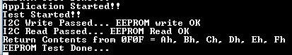

3. Cycle Power. Run only Read Test Section... Pass if return from Read Test is A, B, C... [PASS]

